MODULE END EXAM

PG -DBDA

ROLL NO.- 240840325063

# Cloud

Q1 you are rquired to design a secure and functional cloud infracture using AWS servies.

Create a new IAM user with programmatic access, ensuring that user has a policy granting EC2 Full access.

Answer-

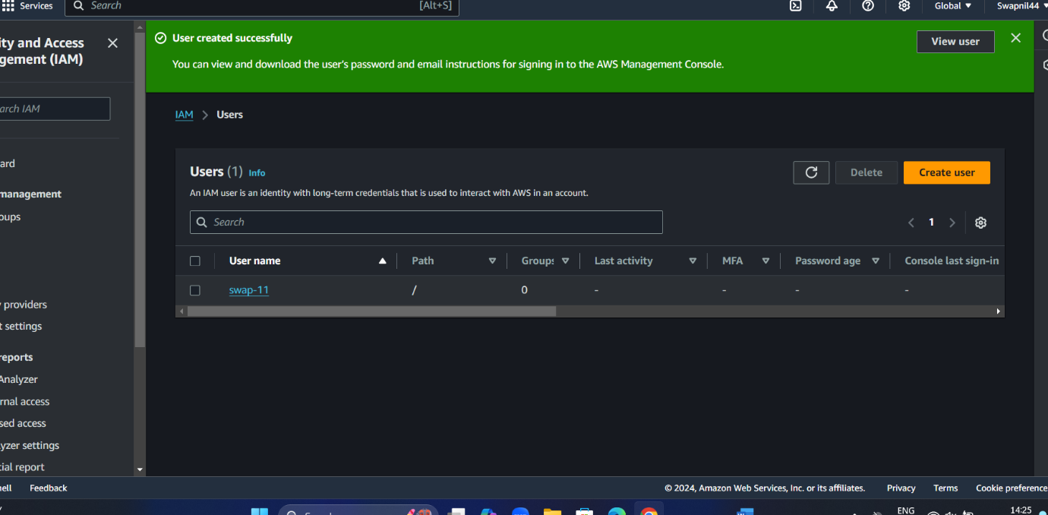

There is we create user in IAM



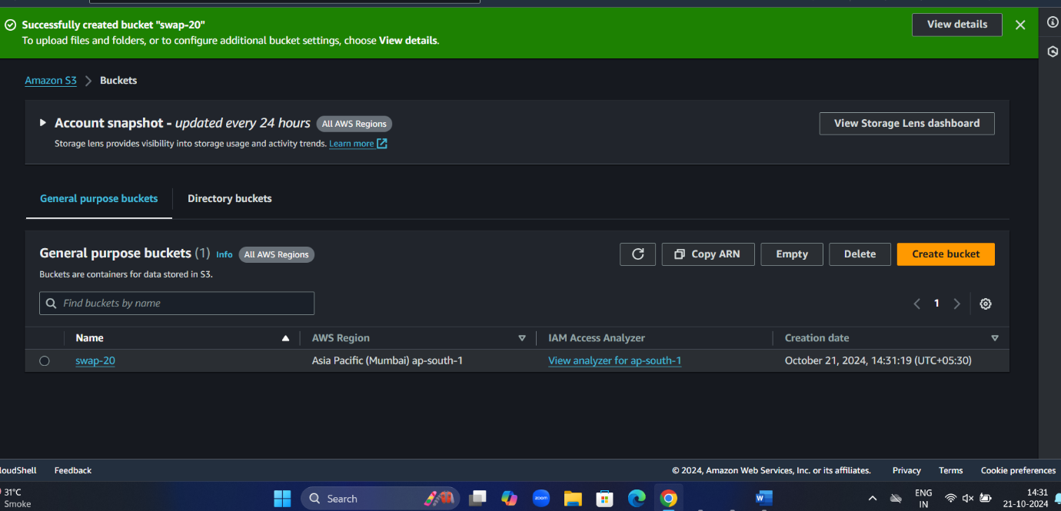

Create bucket in s3 with swap-20 name

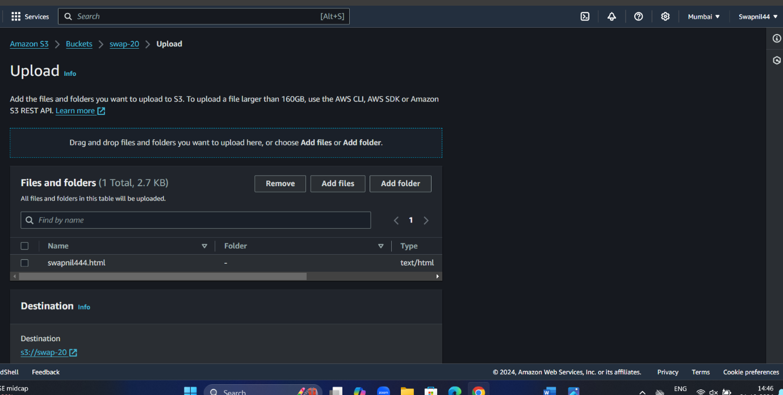

Here is uploaded the file in html format with containing massage “hello ,welcome to my page”

#linux

1.create a new directory

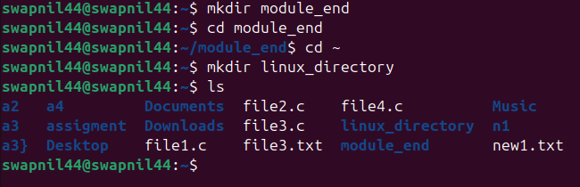

Code – make directory

mkdir linux_directory

code to rename- mv linux_directory new_dir

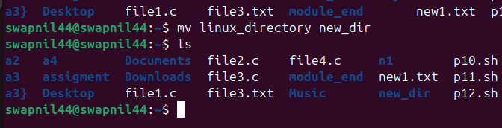

Move- there we used mv command

Mv a4 /home/swapnil44/h1 here we give the path to move file one to other place

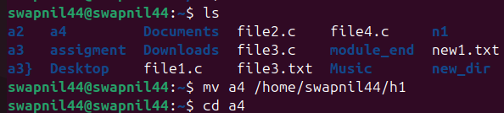

For permission

Chmod u+x new1.txt

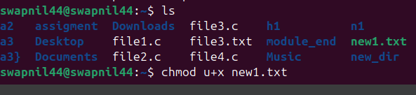

For delete the –

Code rm file3.c

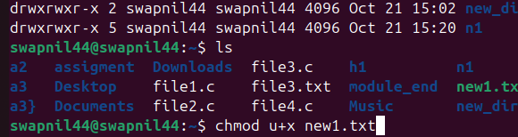

**IAM